Transmission Delay Analysis by Meteo France (SHOM)
January 2008
The graphs in Figures 1 and 2 show the differences between Iridium and Argos in respect to transmission delays.
Both graphs represent the percentage of data available on the GTS vs the time elapsed (delay) after the observation time (in minutes).

The Argos drifters use the DBCP-M2 format. and the transmission scheme as follows: the four most recent observations are transmitted the one after the other over a 6-minute cycle (one obs. every 90s). This way allows to recover a maximum of observations within a shorter time with Argos. GTS data transmission is undertaken for Argos Buoys by CLS/Toulouse or CLS America/Largo and for Iridium buoys by Centre de Meteorlogie Marine of Meteo-France (not yet fully operational). All buoys are SVP-B drifters carrying out hourly measurements.

Figure 1 shows the performances of Argos buoys in the Arctic (cyan line) and in mid-latitude in the Atlantic Ocean (yellow line). Even in the Arctic (north of 85N) – which has better conditions for Argos -, the performances of Argos buoys doesn't reach those of Iridium before 100-minute has elapsed. Metocean Iridium buoys (blue line) emit at HH+11', Marlin buoys (red line) emit on the hour. This explains the delay between the jumps for these respective buoys.
Figure 2 shows the performance of the transmissions in the Indian Ocean at low and mid-latitudes. At mid-latitudes, the performances of Argos buoys appear similar to those of the North Atlantic now : 60% of the expected reports are received within 100 minutes in both area. In the tropical Indian Ocean, the performances of Argos buoys is still below that required : only 35% of the reports are received within 100 minutes.
The performances of Iridium buoys is consistent in all ocean basins sampled here. The 10% missing data at the top of the second graph and the 3% missing at the top of the first graph are due to some unavailability of the data processing (computer or network failure). This will be improved in the future.
Contact:
Pierre Blouch - Meteo-France
E-SURFMAR Programme Manager
Centre de Meteorologie Marine Tel: +33 (0)2 98 22 18 52
13, rue du Chatellier - BP 90411 Fax: +33 (0)2 98 22 18 49
29604 BREST CEDEX (FRANCE) Email: pierre.blouch –at - meteo.fr
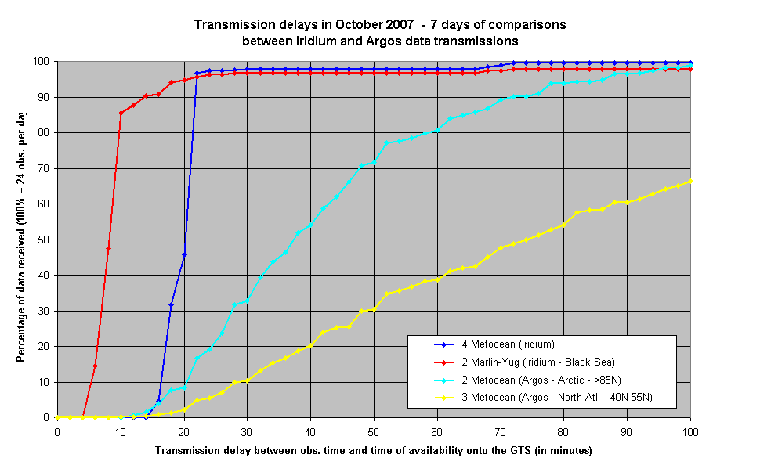Figure 1 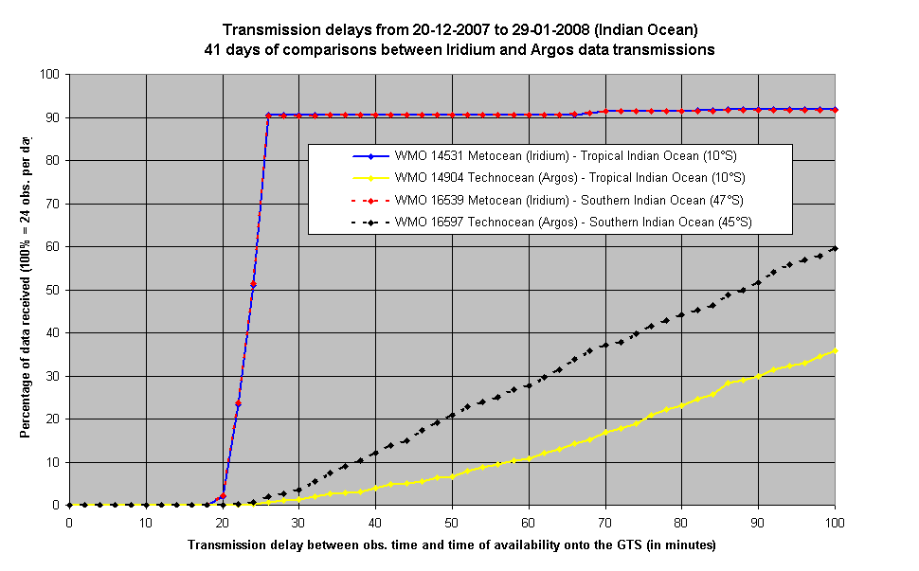Figure 2

