Drifting Weather Buoys – two current examples of their Resilience and their value to Metocean Analysis and Prediction (4-9-09)

Today Friday 4 September 2009, finds a drifting weather buoy approximately 50nm southeast of Bird Is (eastern side of Algoa Bay). It’s track – since December 2007 – is shown below :

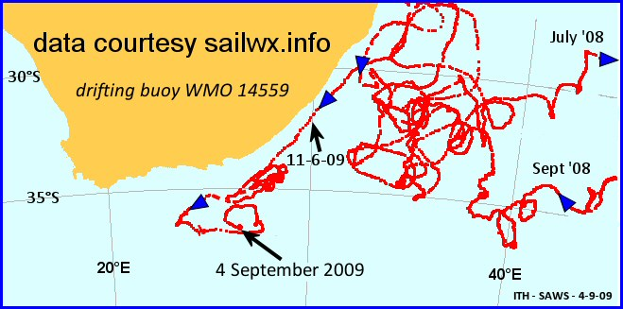

This drifter was deployed by the Norwegian oceanographic research vessel Dr. Fridtjof Nansen on 31 October 2007, about 100 nm east of Quelimane. It spent most of November 2007 looping anti-clockwise down the Mozambique Channel. The spaghetti pattern to the east of the country relates to two distinct, (lengthy) periods as can be seen from the time stamps. This is a useful position in which to have a barometer drifter (SVP-B), as it can help with the analysis of intensifying semi-stationary cut-off lows (cf March 2007 Ballito surge event).
This is not in actual fact a ‘barometer buoy’. It only measures SST. However it should be noted that sea surface temperature is also a very important input parameter for the numerical weather prediction models. And – needless to say – for the operational oceanographic models. See below :
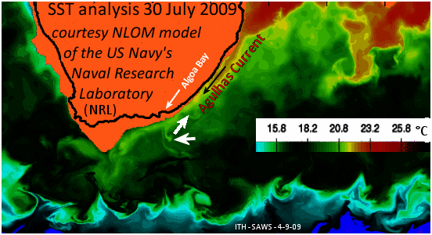

Although this is a model analysis field which relies heavily on the previous model run to supply a 1st guess field , ‘real’ satellite SST data is continuously being assimilated. If one had to rely on high resolution satellite data alone (e.g. MODIS), there would be large areas with no coverage - due to persistent cloud cover and the gaps between orbits. This graphic is from a global version of the model, there is no coverage over the continental shelf.

SST patterns generally give a good indication of ocean surface circulation. Of particular interest on the buoy track are the filaments of warm water breaking away from the Agulhas Current as it passes East London – and further south. This particular SST analysis (30-7-09) falls within the period in which the buoy was looping continuously on the seaward side of the Current. The drogue broke off on 6 December last year, so that the buoy would also have been more affected by wind conditions.

-----------------------------------

SVP-B Drifter 55919

Meanwhile, on the other side of the globe a very special drifting weather buoy is approximately 500 nm southwest of Cape Leeuwin (the southwestern-most point of Australia) :

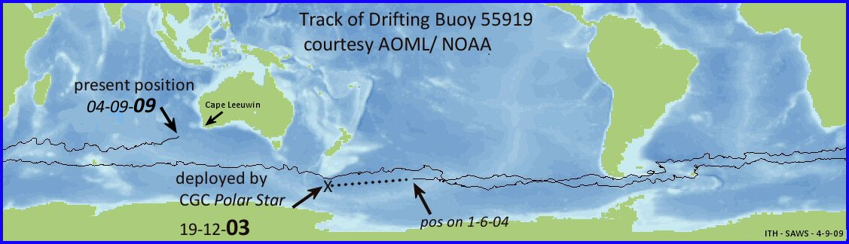

This buoy was deployed in December 2003 by the icebreaker Polar Star, south of New Zealand. Twice it has successfully negotiated the Drake Straits moving from the Southeast Pacific into the Southwestern Atlantic, where it provided valuable observations of air pressure – helping the NWP models to prepare accurate surface analyses. The wave models rely on getting an accurate surface wind field (i.e. sea–level pressure) from the NWP models, to predict heavy swell arriving on the South African coast.
What is more, both SST and air pressure sensors on this buoy are still providing accurate data for the global model analyses – after almost 6 years at sea. Bear in mind – particularly with regard to the latter sensor – that this buoy has twice circumnavigated the globe at latitudes in which individual wave heights are often in excess of 20m

-----------------------------

The design of drifting weather buoys has changed significantly since the 1st major deployment exercise – i.e. during the ‘First GARP Global Experiment (GARP = Global Atmospheric Research Program, 1967-1982). The buoys were generally referred to as ‘FGGE’ buoys and were much larger than the SVP buoys of today :

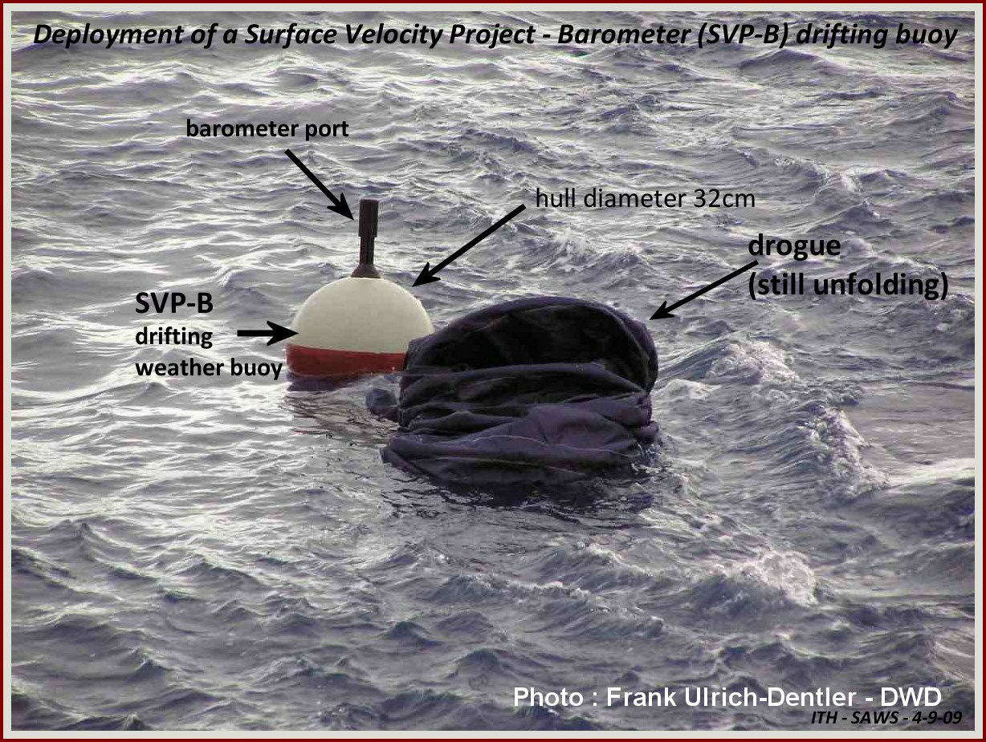

PTO : FGGE buoy ->
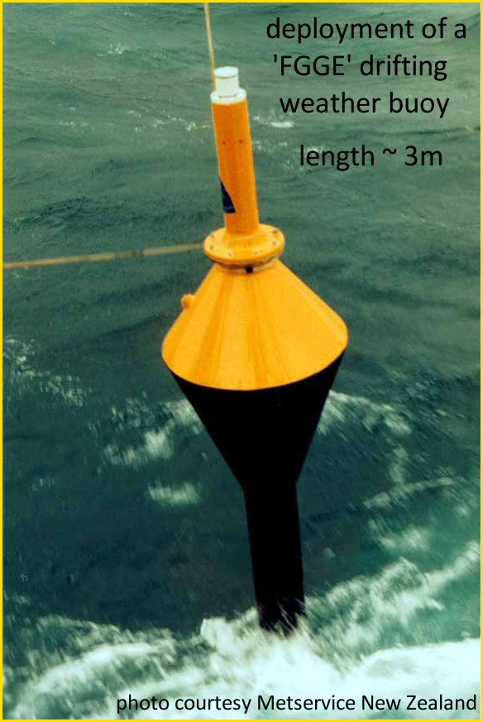

Ian Hunter – SAWS – 4-9-09

