

DBCP Quality Control Guidelines for GTS Buoy Data
Quality control procedures, jointly developed and implemented by the DBCP, GTS Data Processing centres and the operators buoys, currently ensure that surface observations are validated in real-time before insertion on to the GTS (see DBCP Technical Document No. 2) and the poor quality data is removed from the GTS as soon as it is identified. Sub-surface (e.g., from the TAO array) data are further controlled by NOAA / NDBC.
Several other bodies (ECMWF, national weather and oceanographic agencies, GDC, ISDM, etc.) contribute to regular and ad-hoc assessment of data quality.

A well-defined (see Annex A) feedback mechanism ensures that any interventions arising from this off-line quality control (e.g., modifications to individual sensor transfer functions) are implemented into the real-time data processing chain in a coordinated and auditable fashion. Some history of the mechanism is given below.

The Panel will encourage the users of other satellite communications channels and observing systems to benefit from its experience in this regard, with a view to avoiding the many quality pitfalls that beset the acceptance of early drifting buoy data by the operational community.

History
At its seventh session (Toulouse, October 1991), in order to rationalise and speed up status change process of buoys reporting bad data onto the GTS, the Data Buoy Co-operation Panel decided to implement on a trial basis Quality Control Guidelines for buoy data. The guidelines worked effectively on 20 January 1992. It formally endorsed these at its following session (Paris, October 1992).At the tenth session of CBS (Geneva, November 1992), the Guidelines were formally incorporated as part of the World Weather Watch (WWW).
The scheme is based on an Internet distribution list (i.e. mailing list) used by all actors involved in the process. Particularly, when felt necessary, and according to quality control procedures they undertake on their own, Principal Meteorological or Oceanographic Centres (PMOC) responsible for Buoy data Quality Control can make status change proposals by the mean of an Internet mailing list (dbcp-qcjcommops.org). The meteorological centres are indeed in the best position to undertake Quality Control procedures. The JCOMMOPS database contact details are used to forward the proposals to buoy operators. In addition, monthly buoy monitoring statistics produced by PMOCs and WMO/Argos list of identification numbers as well as the list of Principal GTS Co-ordinators are available via the mailing list.

Participants
The following PMOCs are presently participating actively in the Guidelines:
- The Australian Bureau Of Meteorology (ABOM),
- Environment Canada (AES),
- The European Centre for Medium-Range Weather Forecasts (ECMWF),
- Meteo France (CMM, Centre de Meteorologie Marine),
- The Meteorological Service of New Zealand, Ldt. (MSNZ),
- The National Data Buoy Center (NDBC of NOAA, USA),
- The National Center for Environmental Protection (NCEP of NOAA, USA),
- The United Kingdom Meteorological Office (UKMO).

More Information
- Full description of the Guidelines is given in annex A.
- QC message syntax is given in the Appendix to annex A.
- Information regarding the mailing list and how to register is given in annex B
For registering on the mailing list or for details regarding the DBCP QC Guidelines, you can contact the Technical Co-ordinator of the DBCP
- A schematic of the guidelines :
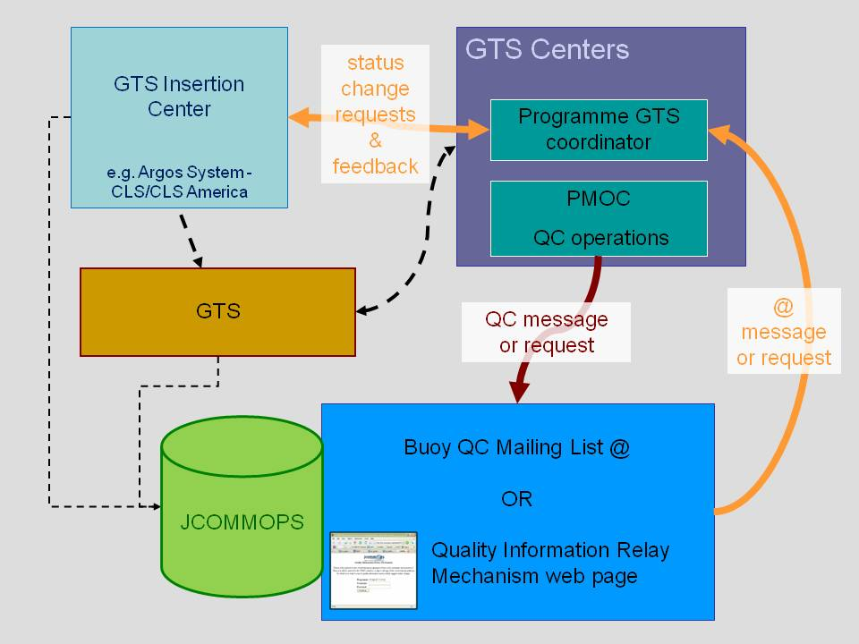
Figure 1. Schematic of the process of implementing the guidelines.

Annex A: Quality Control Guidelines for GTS buoy data
These are principles adopted during previous DBCP sessions:
- Meteorological Centres are in the best position to undertake data Quality Control (DBCP VI).
- Principal Investigators and Meteorological Centres share the responsibility of data Quality Control (DBCP VI).
- JCOMMOPS is in the best position to maintain the link between GTS users and Principal Investigators (DBCP V, VI).
- Argos is responsible for assuring that gross errors are automatically eliminated from reports distributed on GTS (DBCP VI).
In order to realise these principles, the following operating procedures or actions are proposed:

1. PGCs
Each Principal Investigator (PI) of an Argos buoy programme reporting data on GTS, designates a person responsible for making changes on PTT or sensor information present in the Argos GTS sub-system. This person is named the Programme GTS Co-ordinator (PGC).
The Technical Coordinator of the DBCP is in charge of maintaining the list of PGCs.
2. PMOCs
The DBCP requests one or more Agencies or Institutions to volunteer for acting as Principal Meteorological or Oceanographic Centre responsible for deferred time GTS buoy data Quality Control (PMOC). PMOCs work on an operational basis, for given physical variables, either regionally or globally. The following centres are presently acting as PMOCs:
- The Australian Bureau Of Meteorology (BOM, Melbourne, Australia);
- Environment Canada (AES, Edmonton, Canada);
- The European Centre for Medium Range Weather Forecasts (ECMWF, Reading, United Kingdom);
- The Icelandic Meteorological Office (IMO, Reykjavik, Iceland);
- The Japan Meteorological Agency (JMA, Tokyo, Japan);
- Meteo-France (the Centre de Meteorologie Marine, Brest, France);
- The Meteorological Service of New Zealand, Ltd. (NZMS, Wellington, New Zealand);
- The National Data Buoy Center (NOAA/NDBC, Stennis Space Center, Mississippi, USA);
- The National Center for Environmental Prediction (NOAA/NCEP, Camp Spring, Maryland, USA);
- The Pacific Marine Environmental Laboratory (NOAA/PMEL, Seattle, Washington, USA);
- The United Kingdom Meteorological Office (UKMO, Bracknell, UK).
- The South African Weather Bureau (SAWB, Pretoria, South Africa).
National Focal Points for Drifting Buoy Programmes are requested to designate National PMOCs, and possibly to act themselves as PMOCs.
3. Automatic distribution list (mailing list).
It is proposed that the mechanism for exchanging QC information among the Guidelines Participants shall be an INTERNET distribution list. PMOCs send the proposed messages to a unique INTERNET address which name is dbcp-qcjcommops.org. "node_path" depends upon who actually operates the distribution list. The full INTERNET address of the Distribution List shall be circulated among the Guidelines participants.
The list is operated at JCOMMOPS
dbcp-qcjcommops.org
The messages are then automatically forwarded to all the individual addresses from a maintained distribution list. Adding, reading, modifying, or deleting a name form the list can be done via INTERNET messages according to an agreed format.
- 3.1 ECMWF, NOAA/NCEP/NCO, METEO FRANCE, and UKMO buoy monitoring statistics are delivered onto the INTERNET Distribution List.
- 3.2 Any suggestion for modification (i.e. recalibrate or remove sensor from GTS) or any problem noticed (e.g. bad location) on a drifting buoy reporting data on GTS should be placed on the Distribution List. Meteorological Centres are encouraged to make such suggestions.
- 3.3 Any feed back available on a recalibration actually implemented shall be placed on the distribution list.
4. Operating Procedures for dealing with Potential Problems on GTS (Drifting and Moored Buoy data)
- 4.1 PMOCs noticing potential problems on GTS can suggest an action via the INTERNET Distribution List. A standardised, telegraphic format is proposed (see Appendix): one message per platform or per sensor, showing the WMO number and the proposed change, directly in the "subject" line, with additional comments appearing in the text itself, using a free format if felt necessary by the PMOC (see example in Appendix).
- 4.2 PMOCs noticing bad location or bad sensor data episodically appearing on GTS message can copy the message on the INTERNET Distribution List, indicating from which source the message was transmitted. Although it is recommended that LUT operators access to the INTERNET Distribution List as well, if not possible, the Technical Co-ordinator of the DBCP or the responsible PGC or a designated PMOC (see paragraph 4.7.2) would keep them informed by telefax or another mean.
- 4.3 The JCOMMOPS database is used to forward the PMOC message to the buoy operator. It is recommended that the PGC waits for a few days before taking any action unless he/she is confident enough in the quality status of the data. Other meteorological centres may therefore have an opportunity to also comment on a particular problem. Other data users who are on the INTERNET Distribution List are encouraged to check the received messages regularly.
- 4.4 Then, if the PGC accepts the modification, he requests the adequate Argos centre (i.e. CLS or SAI) to make the change. In order to keep the GTS user community informed, Service Argos announces the change as soon as possible by means of the INTERNET Distribution List (a standardised message is proposed in the Appendix) and also effects the change as prescribed. It is recommended that the PGC also requests appropriate LUTs to implement the same changes.
- 4.5 If the PGC is not willing to go ahead with a proposed change they will contact the Argos representative or GTS manager at their center and make the change, they may then send an email to the distribution list to inform PMOCs of the change.
- 4.6 Local User Terminals are urged to adopt these Quality Control Operating Guidelines.
- 4.6.1 It is desirable that LUTs not willing to participate should distribute drifting buoy data on GTS only to local users (i.e. no global GTS distribution).
- 4.6.2 LUT operators participating and registered on the INTERNET Distribution List are encouraged to inform the participants back by the mean of the Distribution List each time a change is implemented, using the same format as Argos (see paragraph 4.4).
5. DBCP, WMO and IOC Secretariats
They will promote these Quality Control operating guidelines and encourage participation in this scheme.

Operating QC Guidelines for buoy data

Appendix

Standardized Format for Information Deposited on the INTERNET Distribution List

Notations:
- UPPERCASES in bold are constant field values and will appear "as shown" in the subject line; e.g. ASK will appear as the 3 characters 'ASK' in the subject line.
- Lowercases are used to designate variable data fields; If the name of the field is on 5 characters, then the field value must be coded using 5 characters (completed with spaces if necessary); e.g. ttt can be coded as 'AP ' to indicate Air Pressure or as 'SST' to indicate Sea Surface Temperature.
- The line 12345678901234567890123456789012 is just here to indicate the number of characters used (32 maxi) and their position; It has no other specific meaning.

1. Proposals for status change (by Meteo Centres, i.e. PMOCs):
When detecting bad data circulating on GTS, Meteorological Centres can propose changes on buoy status (remove or recalibrate sensor) via the INTERNET Distribution List. Proposals are done using a standardised telegraphic format in the subject line. Comments can be added in the body text.
Format:
12345678901234567890123456
hASK ttt wmo## ppp ovalue
Meaning:
It is proposed to remove or recalibrate one or more sensors for one given
buoy.
h : One figure, 1 to 9, to indicate the number of the request for the same
buoy, for example, the first proposal would be coded 1ASK..., and if
another Meteo Centre feels necessary to comment on the same proposal,
it can suggest another action and name it 2ASK, etc...
ttt : Type of proposal:
RMV : for removing sensor data from GTS
REC : for recalibrating a sensor
CHK : for checking data carefully; in that case, it is recommended to
add in the body text of the message: (1) Example(s) of the
suspicious or erroneous GTS message(s), (2) the GTS bulletin
header that was used (i.e. originating centre for the bulletin),
(3) a description of the problem and (4) if possible, proposed
action to solve it.
COM : for commenting on a particular problem. Explanation is given
in the body text of the message.
wmo## : WMO number of the buoy (A1bwnbnbnb) or LIST if more than one buoy
are concerned.
It is preferable to make status change proposals for different buoys on
distinct messages. However, in case the LIST option is used, proposals can
be detailed in the body text of the message: it is recommended to state the
proposal for each buoy by starting with a line encoded according to the
standard format followed by the comments on a few lines included inside
brackets; then the next proposal can be listed etc.. General comments can
be included in free format after the last proposal.
Example for the body text in case more than one proposal are included
(subject line could be 1ASK CHK LIST AP):
1ASK CHK 61412 AP
(this buoy has been transmitting erroneous data
in the last 2 week)
1ASK CHK 54814 AP
(this buoy shows strong departure of Air Pressure
from the first guess field)
...
Mr. W. Xyz., National Meteorological Service.
ppp : Physical variable (sensor) to consider:
AP : Air Pressure (coded as 'AP ')
AT : Air Temperature (coded as 'AT ')
SST : Sea Surface Temperature
WD : Wind Direction (codes as 'WD ')
WS : Wind Speed (coded as 'WS ')
APT : Air Pressure Tendency
POS : Position of the buoy
TZ : Subsurface temperatures (coded as 'TZ '): The depths of
the probes and proposed actions should be placed in the body
text, not in the subject line (not enough room)
ALL : All buoy sensors (e.g. remove all buoy data from GTS)
Blank: (coded as 3 space characters, i.e. ' ') Informations are
detailed in the body text.
o : Operator to use for proposed recalibration (mandatory and used only when
ttt='REC'):
+ : Add the following value to the calibration function
- : Subtract the following value from the calibration function
* : Multiply the calibration function by the following value
(e.g. rate for recalibrating wind speed sensor)
value: Value to use for proposed recalibration (mandatory and used only
when ttt='REC'); the value is coded on 5 characters and completed
with space characters if necessary. It is provided using the
following physical units:
Air Pressure : Hecto Pascal
Temperatures : Celsius degrees
Wind speed : m/s
Wind Direction : Degrees
Air Pressure Tendency : Hecto Pascal
Positions : Degree + Hundredth
Rate : No unit

Examples:

From Date Subject

FLETCHERMETDP1.MET.CO.NZ 10-Oct-1998 1ASK REC 17804 AP +2.2
ARADFORDEMAIL.METO.GOVT.UK 11-Oct-1998 1ASK RMV 62501 ALL
BLOUCHIFREMER.FR 11-Oct-1998 2ASK REC 17804 AP +2.4
MBURDETTENDBC.NOAA.GOV 11-Oct-1998 1ASK CHK 44532 POS
GXBORVILLE.HO.BOM.GOV.AU 12-Oct-1998 1ASK REC 44704 WS *1.5

Message1: NZMS proposes to recalibrate Air Pressure sensor of buoy
17804 by adding 2.2 hPa.

Message2: UKMO proposes to remove buoy 62501 from GTS distribution.
Explanations are given in the body text.

Message3: Meteo France comments (2ASK) on NZMS proposal for
recalibrating air pressure sensor of buoy 17804. Meteo
France suggests to add +2.4 hPa instead of +2.2 hPa.
Argumentation is provided in the body text.

Message4: NDBC suggests to check positions of buoy 44532. Details are
given in the body text, including copy of one suspicious GTS
message, the GTS bulletin header, and a description of the
error.

Message5: BOM proposes to recalibrate Wind speed sensor of buoy 44704,
by multiplying data by 1.5.

2. Argos or LUT answer for changes actually implemented

When a change is implemented on GTS platforms, a message is normally
forwarded to the INTERNET Distribution List, by Argos or the considered LUT,
no later than 24 hours after the change was implemented. All the information
is encoded in the subject line, the body text is empty. The format of the
subject line is as follow:

Format:

123456789012345678901234567890123456
cccc ttt wmo## ppp ovalue yymmddhhmm

Meaning:
Argos (i.e. the French Global Processing Center of Toulouse (FRGPC) or the
US Global Processing Center of Landover (USGPC)) or Local User Terminals
(LUT) inform the INTERNET Distribution List each time a change is actually
implemented on a buoy status.

cccc : Originating Center:

LFPW = FRGPC, Toulouse
KARS = USGPC, Landover
ENMI = Oslo LUT
BGSF = Sondre Stromfjord LUT
CWEG = Edmonton LUT

ttt, wmo##, ppp, ovalue: Same as for paragraph 1. In addition, for
recalibrations, when the transfer function has been completely modified,
ovalue can be coded as a question mark followed by 5 space characters,
i.e. '? ' , to indicate that the change is not as simple as
a +X, -X or *X transformation.

yymmddhhmm: UTC time the change was implemented: Format=Year
(2 digits), Month (2 digits), Day of the month (2 digits),
Hour (2 digits), and Minutes (2 digits).

Example:

From Date Subject
GTSGTSVAX.ARGOSINC.COM 14-Oct-1998 KARS REC 17804 AP +2.3 9810141216
GTSGTSVAX.ARGOSINC.COM 14-Oct-1998 KARS REC 33809 AP ? 9810141306

Message6: Buoy 17804 Air Pressure sensor was recalibrated by adding
+2.3 hPa. the change was implemented at 12h16 UTC the 14
October 1998. As you may notice, two proposal had been
made for this buoy: NZMS proposed +2.2 hPa and Meteo France
proposed 2.4 hPa. The Technical Co-ordinator of the DBCP
contacted both agencies and it was then decided to apply
a 2.3 hPa correction.

Message7: Buoy 33809 Air Pressure sensor was recalibrated. The change was
implemented at 13h06UTC the 14 October 1998. The question mark
'? ' indicates that the transfer function was completely
modified.

3. PGC response if the proposal was denied

Format:

12345678901234567890123456
DENI ttt wmo## ppp ovalue

Meaning:
The proposal was denied by the Principal GTS Co-ordinator (PGC) of the
drifting buoy programme. No action was taken. Complementary information
can be included in the body text.

ttt, wmo##, ppp, ovalue: same meaning as in paragraph 1. ovalue is
mandatory and used only when ttt='REC'.

Example :

From Date Subject
BLOUCHIFREMER.FR 15-Oct-1998 DENI RMV 62501 ALL

Message8: In the body text: Data were sent on GTS before deployment by
mistake. The buoy is now deployed and data look good. There is
therefore no need for removing data from GTS distribution.

4. Buoy monthly monitoring statistics

Format:

12345678901234567890123456789
STAT center ppp year mm dd

Meaning:
The monitoring statistics are available in the body text. Format is free
for the moments but it is recommended that each center uses the same format

center: Name of the center producing the statistics, e.g.

ECMWF = European Center for Medium Range Weather Forecasts
NCO = NOAA NCEP Central Operations
CMM = Meteo France, Centre de Meteorologie Marine
UKMO = United Kingdom Meteorological Office

ppp: Type of physical variable concerned or ALL if many variables are
included. Same as for paragraph 1 (i.e. AP, AT, WD, WS, SST ...)

year: Year concerned (e.g. 1998)

mm: Month concerned (e.g. 08 for August)

dd: Last day of the 1-month period concerned. It is optional and used
only if the 1-month period does not end on the last day of the
month. For example dd=15 if the 1-month period concerned is
16 July to 15 August.

Example :

From Date Subject
BLOUCHIFREMER.FR 02-Oct-1998 STAT CMM ALL 1998 09

Message9: The September 1998 monitoring statistics for many geo-physical
variable and produced by the Centre de Meteorologie Marine of
Meteo France are available in the body text.

Annex B: DBCP QC Guidelines distribution list (mailing list)
Once registered on the mailing list, you will automatically receive any message posted by anybody onto the mailing list. For posting messages onto the mailing list, just send an Email to the following address (address updated in February 2009):

dbcp-qcjcommops.org

