INTERGOVERNMENTAL OCEANOGRAPHIC COMMISSION WORLD METEORLOGICAL ORGANIZATION
Téléphone: +33.1 45 68 10 00 Téléphone: +41.22 730 82 37


Télégrammes: UNESCO PARIS Télégrammes: METEOMOND GENEVE
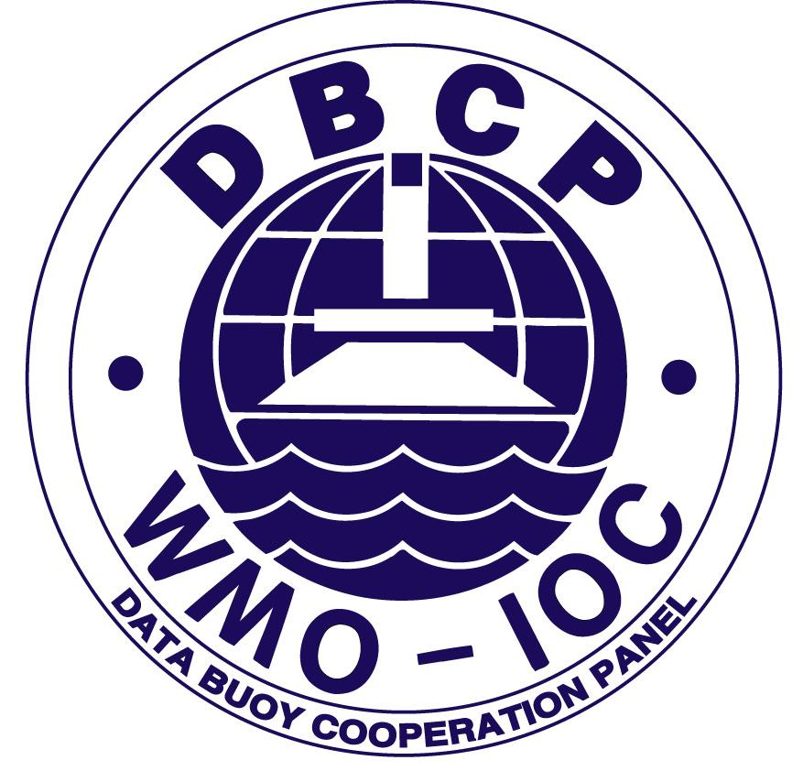
Télex: 204461 Paris Télex: 41 41 99 OMM CH
Facsimilé: +33.1 45 68 58 12 Facsimilé:+41.22 733 02 42
Internet: y.treglos@unesco.org Internet: dexter@www.wmo.ch
1, rue Miollis, Paris, France Case postale n° 2300,
CH-1211 Genève 2, Suisse

David Meldrum Hester Viola
Chairman, DBCP Technical Coordinator, DBCP
SAMS, Dunstaffnage JCOMMOPS, 8-10 rue Hermès
OBAN PA37 1QA 31520 Ramonville Saint-Agne
United Kingdom France
Tel: +44 1631 559 273 Tel:+33.5 61 39 47 82
Facsimilé: +44 1631 559 001 DATA BUOY CO-OPERATION PANEL Facsimilé: +33.5 61 75 10 14
Email: dtm@sams.ac.uk Email: viola@jcommops.org

Dear buoy operator,
The Argos User Centre (of CLS or CLS America) has indicated that your Argos program will start shortly. As the Technical Coordinator of the Data Buoy Cooperation Panel (DBCP), I would like to:
- offer any support you may need in preparation for and ongoing operation of this ocean program
- ask you to allow distribution of your data on the Global Telecommunication System (GTS) of WMO.
Some examples of the benefits you can gain are outlined on the DBCP website.
I will also be happy to send you any of the DBCP or SOT technical documents of interest (see document list). All assistance on DBCP and SOT, including documentation, is free of charge.
The data arising from your program, as well as providing you with the data and information you need, has the potential to benefit the broader scientific community. A large number of Argos users already distribute their data on the Global Telecommunication System which assists weather forecasting, ocean modelling and climate research (for more on the GTS, please see paragraph on GTS within this document). As well as the clear benefits to the community, a direct benefit for you could be that once your data is distributed onto the GTS, many nations' weather centers will monitor the quality of the data produced in your program and identify possible issues with data, as a matter of course.
Hopefully you are interested in distributing your data onto the GTS. If so, please either contact your CLS representative or send me an e-mail at violajcommops.org, to authorize distribution and allow CLS to collect the information needed to proceed.
Good luck with your program.
Please contact me if you require assistance or information concerning the GTS.

Regards,
Hester Viola
Technical Coordinator of the DBCP
JCOMMOPS

